Servlets is a technology/spec in Java EE that allows us to develop dynamic web applications using Java.

Servlet is a Java program that runs on the web server or web container.
Servlet code runs from a web container.

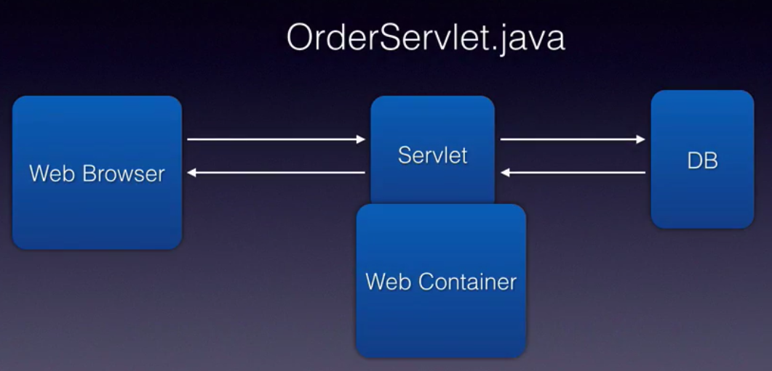

Life cycle methods and phases :

Servlet life cycle has 3 methods :
- init(),
- service(), and
- destroy()

4 initialization phases :
- instantiation – loading the servlet class into memory.
- initializatoin
- servicing
- destruction.

Life cycle methods are called by the web container. Web container first goes through the instantiation phase where in it will create a instance of our servlet class by loading the class into memroy.

Init( ) method is called only ONCE. It will contain the initialization code, like database connection.

Service( ) method is where all our business logic goes. All processing logic will be part of service method. It will be called for each request.

Destroy( ) method is called only ONCE. It will contain clean up code.

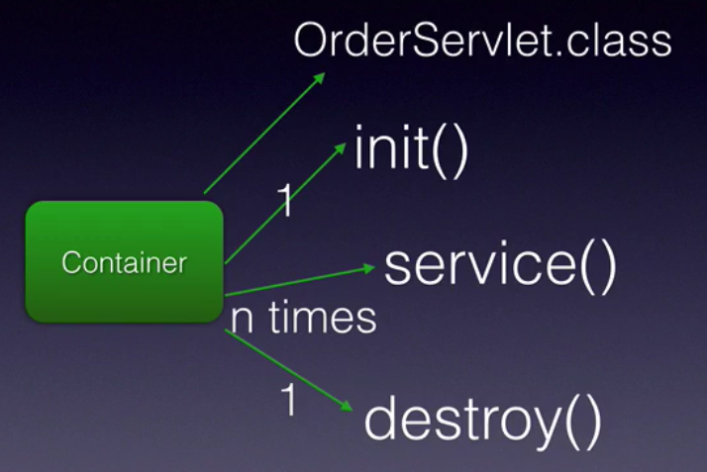

Web application folder structure :

Standard folder structure that every Java EE web application should follow in order for it to be deployed on a application server or web container like Tomcat.

WEBAPP – is nothing but your web application root folder.

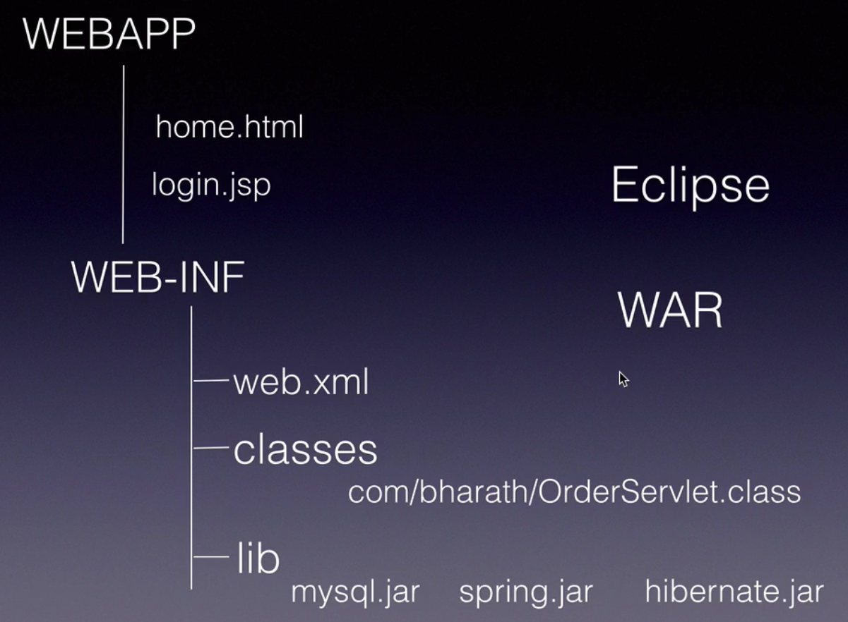

web.xml – this is nothing but deployment descriptor file.

Servlet annotations :

3.0 version of servlets introduced annotations that can be used to configure various servlet components instead of using web.xml.

Examples : @WebServlet, @WebInitParam, @WebFilter, @WebListener, etc.

web.xml will override the configuration that you specified with annotations.

Hello World Servlet :

3 steps :

1. Project creation
2. Web Resource development – creating the servlet class
3. Create the deployment descriptor – configuring the servlet class

Step 1 :

File -> New -> Dynamic Web Project : Give Project name(this name is used for webapp name) : ServletBasics , click Next -> Next -> select the checkbox : 'Generate web.xml deployment descriptor' -> click Finish.

Eclipse will create folder structure as :

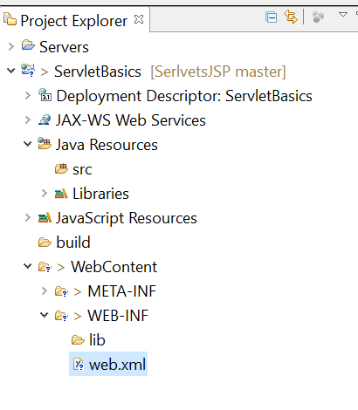

Step 2 : Creating the Servlet class

Create a class named 'HelloWorldServlet' in the package 'com.rdayala.servlets'. Also, make sure the class extends GenericServlet class. It creates the class like below :

public class HelloWorldServlet extends GenericServlet {

@Override
public void service(ServletRequest arg0, ServletResponse arg1)
throws ServletException, IOException {
// TODO Auto-generated method stub

}

}

We have written some code in our first servlet class :

public class HelloWorldServlet extends GenericServlet {

@Override
public void service(ServletRequest request, ServletResponse response)
throws ServletException, IOException {

response.setContentType("text/html");
PrintWriter out = response.getWriter();
out.println("<html>");
out.println("<body>");
out.println("<h1>Hello Servlets World!!</h1>");
out.println("</body>");
out.println("</html>");
}
}

Step 3: Configuring the servlet in deployment descriptor web.xml

<servlet>
<servlet-name>HelloServlet</servlet-name>
<servlet-class>com.rdayala.servlets.HelloWorldServlet</servlet-class>
</servlet>
<servlet-mapping>
<servlet-name>HelloServlet</servlet-name>
<url-pattern>/hello</url-pattern>
</servlet-mapping>

After you have configured your servlet in the deployment descriptor, you can run your servlet class on the server. (use the option : Run As -> Run on Server
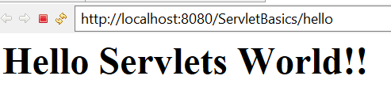

Getting input from the user and processing on the server using Servlet and sending the result back :

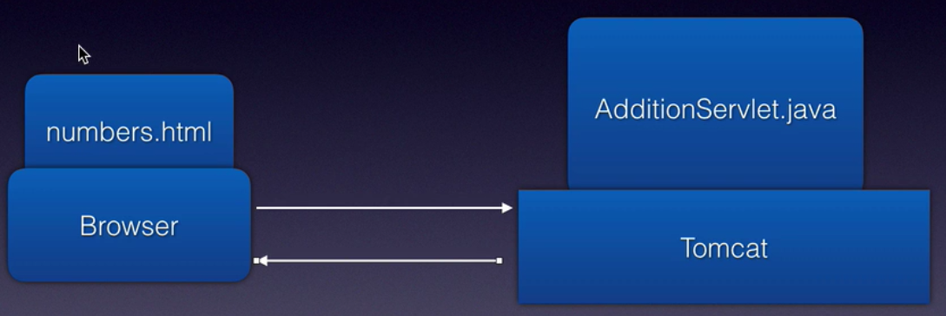

Just a simple use case, sending 2 numbers from the user to the server, retreiving them in the servlet, adding them and sending the result back to the user/browser.

Numbers.html :
<html>
<body>
<form action="add">
<h2>Enter the numbers</h2> <br/>
Number 1: <input type="text" name="number1"/><br/><br/>
Number 2: <input type="text" name="number2"/><br/><br/>
<input type="submit" name="submit"/>
</form>
</body>
</html>

Servlet class is like : AdditionServlet.java

@Override
public void service(ServletRequest request, ServletResponse response)
throws ServletException, IOException {

Integer num1 = Integer.parseInt(request.getParameter("number1"));
Integer num2 = Integer.parseInt(request.getParameter("number2"));

PrintWriter out = response.getWriter();
out.println("The sum is : " + (num1+num2));

}

configuring the new AdditionServlet in deployment descriptor (web.xml) :

<servlet>
<servlet-name>AdditionServlet</servlet-name>
<servlet-class>com.rdayala.servlets.AdditionServlet</servlet-class>
</servlet>
<servlet-mapping>
<servlet-name>AdditionServlet</servlet-name>
<url-pattern>/add</url-pattern>
</servlet-mapping>

When you run the program :
